IT- 603 Lab 2: C++ Compilation, Debugging,
Build Systems, and Version Control
Kunal Adwani | 202612050 | Kunal-63/202612050-IT603
1 Part A: GCC/G++ Compilation Process
What to do
- Write a simple C++ program (e.g., a program that computes factorial or checks primality).
- Compile it using g++ and run the executable.
- Explore each stage of compilation separately using compiler flags:
  - Preprocessing – generate the preprocessed output (-E)
  - Compilation – generate assembly code (-S)
  - Assembly – generate the object file (-c)
  - Linking – produce the final executable
- Note down the file produced at each stage and briefly describe what changed.
- Try compiling with different optimization levels (-O0, -O2) and compare.
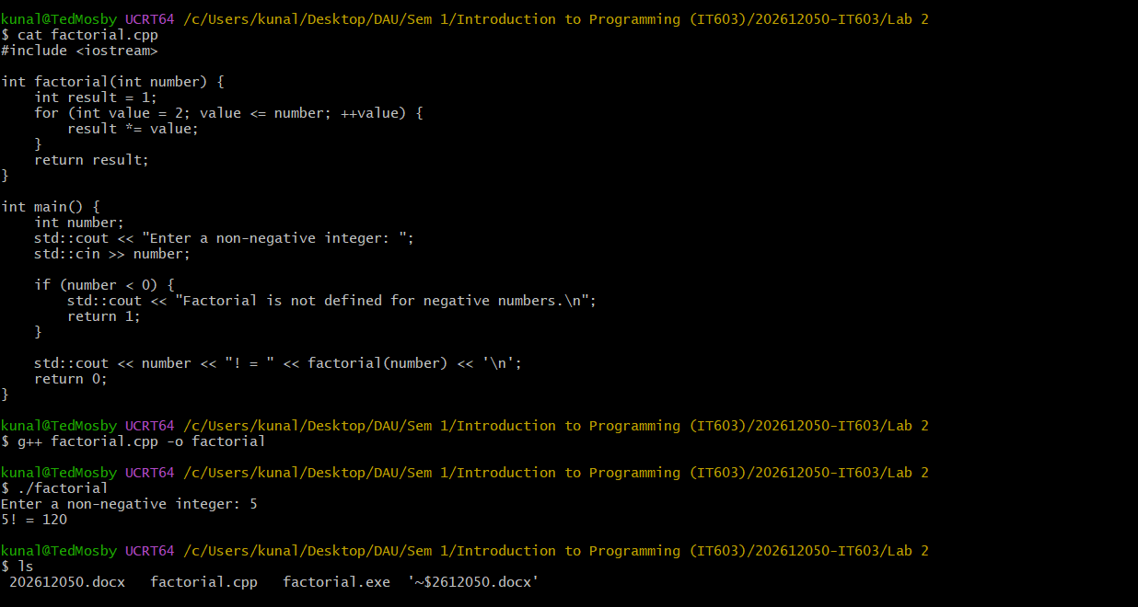
Stage 1 – Preprocessing
- #include <iostream> is expanded.
- Preprocessor directives are handled.
- Macros are expanded.
- The actual C++ source is converted into a much larger preprocessed source file.
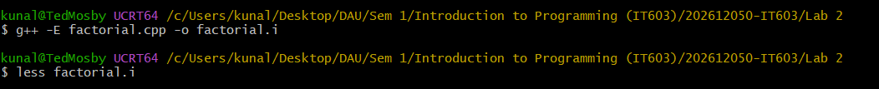
Stage 2 – Compilation
- C++ source is converted into assembly language.
- The compiler performs syntax and semantic analysis.
- Optimizations may be performed depending on the optimization flag.
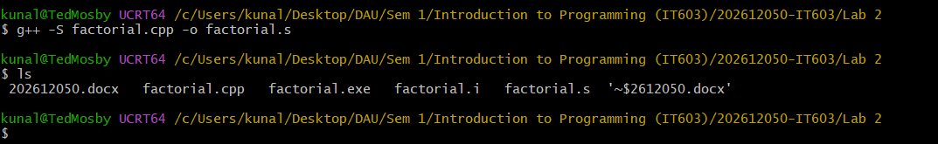
Stage 3 – Assembly
- Assembly code is converted into machine/object code.
- The result is an object file.
- It is not yet a complete executable because library functions such as iostream still need to be linked.
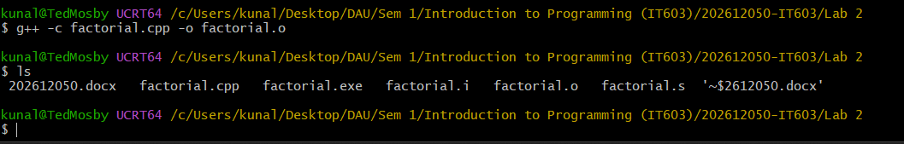
Stage 4 - Linking
- The linker combines your object code with required libraries.
- References to functions such as cout and cin are resolved.
- A complete executable program is produced.
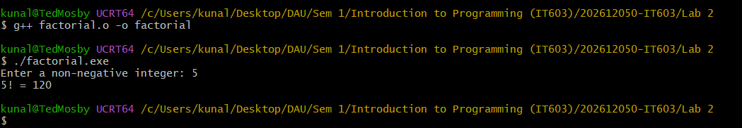
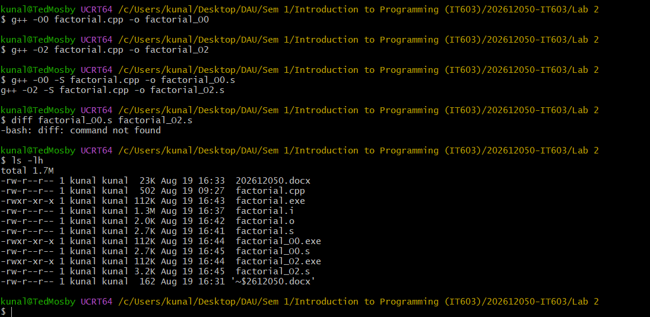
The compilation process transforms the C++ source code into preprocessed code, assembly code, object code, and finally an executable. The -O0 option produces minimally optimized code, while -O2 applies compiler optimizations that can improve execution performance and change the generated assembly.

2 Part B: Debugging Using GDB
What to do
- Take a C++ program with a deliberate bug (e.g., an off-by-one error or a segmentation fault
- from an out-of-bounds array access).
- Compile it with debugging symbols enabled (-g).
- Load the program in GDB and:
  - Set breakpoints at relevant functions/lines.
  - Step through the program line by line.
  - Inspect variable values at different points.
  - Use a watchpoint to track when a variable changes.
  - Identify and fix the bug.
- Record the sequence of GDB commands used and the final fix.
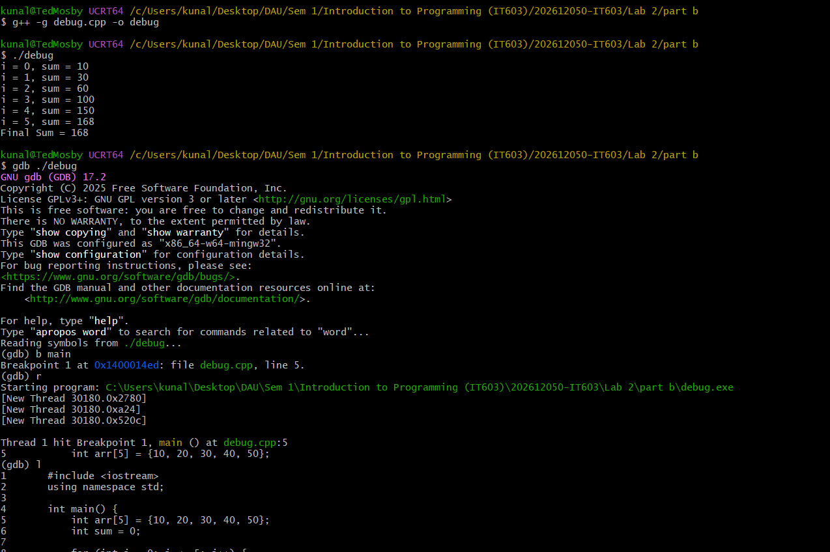
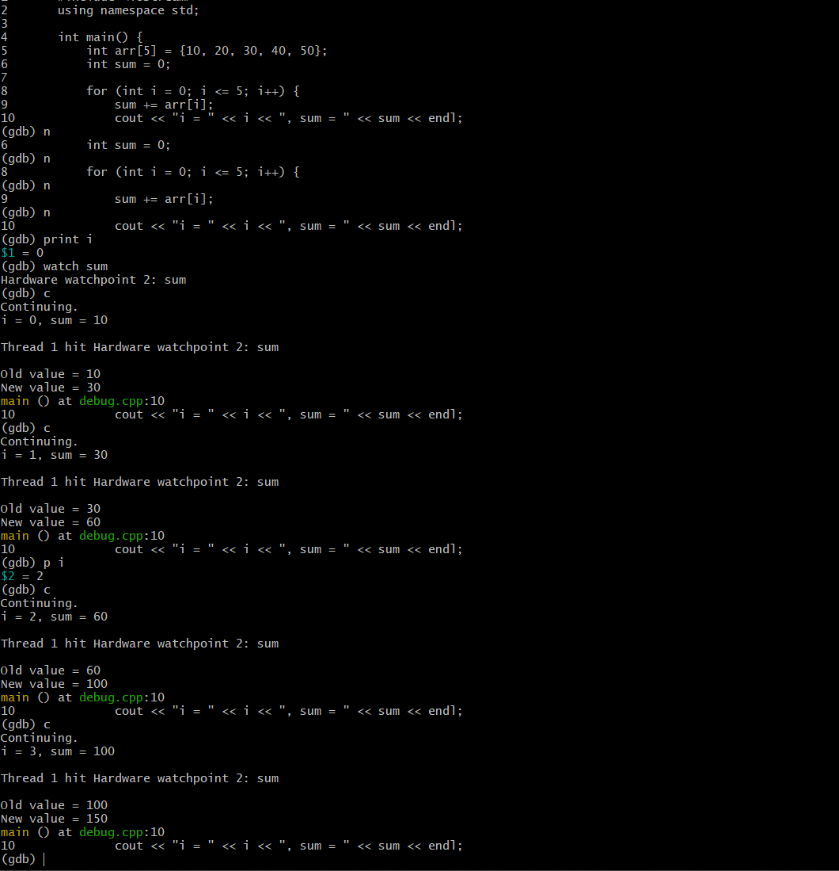
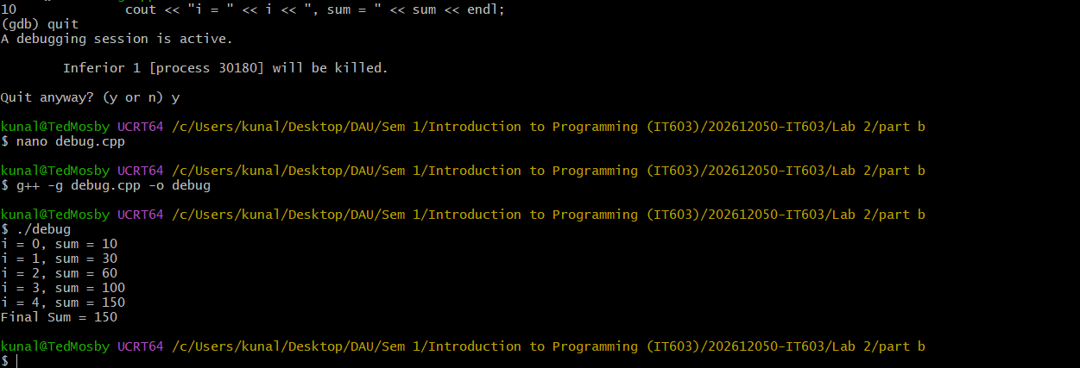

3 Part C: Multi-file Programs
What to do
- Split a single-file program into multiple files: separate header (.h) and source (.cpp) files for at least one class or module, plus a main.cpp.
- Use header guards (or #pragma once) correctly.
- Compile the multi-file program manually using g++, first generating object files for each source file and then linking them together.
- Explain why splitting code into multiple files is useful for larger projects.
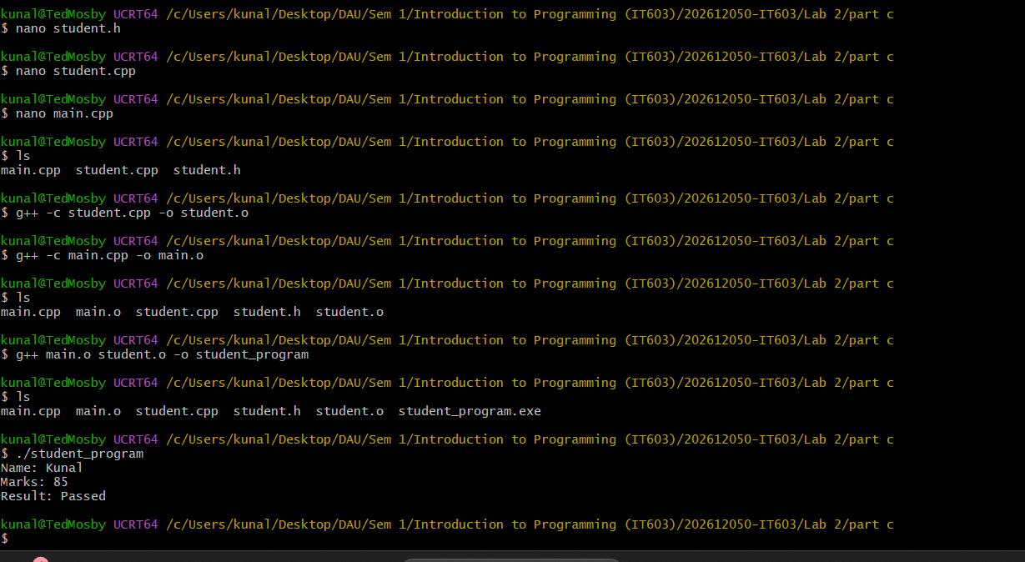
Why use multiple files?
- Better organization
- Easier maintenance
- Code reusability
- Faster compilation
- Team development

4 Part D: Makefiles
What to do
- Write a Makefile for the multi-file program from Part C.
- The Makefile should include:
  - Rules to compile each source file into an object file.
  - A rule to link all object files into the final executable.
  - A clean target to remove generated files.
- Use variables (e.g., CXX, CXXFLAGS, OBJS) instead of hardcoding values.
- Run make and make clean to confirm the build works end-to-end.
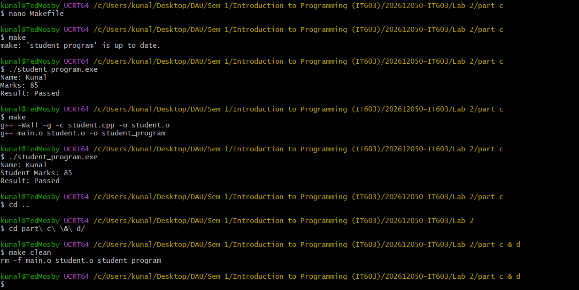
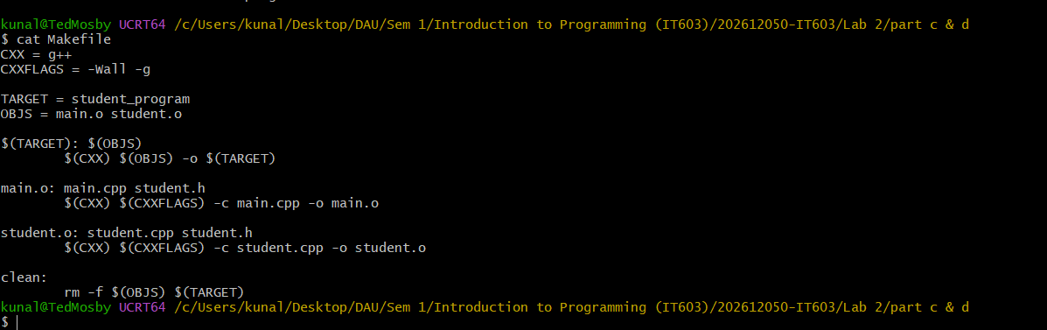

5 Part E: Introduction to Git and Version Control
What to do
- Initialize a Git repository for the project from Parts C and D.
- Create a .gitignore file to exclude compiled binaries and object files.
- Make an initial commit, then:
  - Make a small code change and commit it separately.
  - View the commit history using git log.
  - Create a new branch, make a change on it, and merge it back into the main branch.
- Briefly note the purpose of git status, git diff, and git checkout based on your usage.
